Pokémon Data Analysis

What is Pokémon Go?

Pokémon Go is a free-to-play, location-based augmented reality game developed by Niantic for iOS and Android devices. It was released in July 2016 and in a few selected countries. You can download Pokémon for free of cost and start playing. You can also use PokéCoins to purchase Pokéballs, the in-game item you need to be able to catch Pokémons with. Let us see how to be performing Pokémon data analysis.

Dataset Description:

The dataset consists of 11 columns and their respective description is as follows:

* **Pokemonid_Number**: This column represents the ids of every Pokémon.
* **Name**: This column represents the name of a Pokémon.
* **Type 1**: This column represents the property of a Pokémon.
* **Type 2**: This column represents the extended property of the same Pokémon.
* **Total**: This column represents the sum of all character points of a Pokémon (Hit Points, attack, defense, special attack, special defense, and speed).
* **Hit Points (HP)**: This column represents Pokémon Hit Points, which is a value that determines how much damage a Pokémon can receive. When a Pokémon's HP is down to ‘0’, the Pokémon will faint. HP is the most frequently affected stat of them all, as a depleting HP is a key factor in winning a battle.
* **Attack**: This column represents the Attack stat.
* **Defense**: This column represents the Defense stat.
* **Special Attack (Sp.Atk)**: This column represents a Pokémon’s Special Attack stat.
* **Special Defense (Sp. Def)**: This column represents a Pokémon’s Special Defense stat.
* **Speed**: This column represents the speed stat of a Pokémon.

**Glimpse of Dataset**:

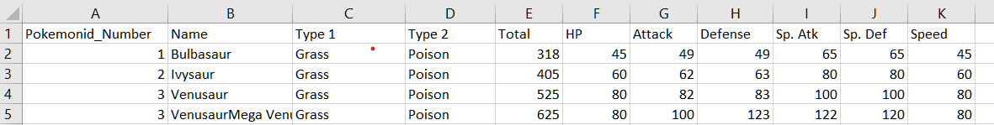

Let us begin by creating a table to hold the dataset, as shown below.

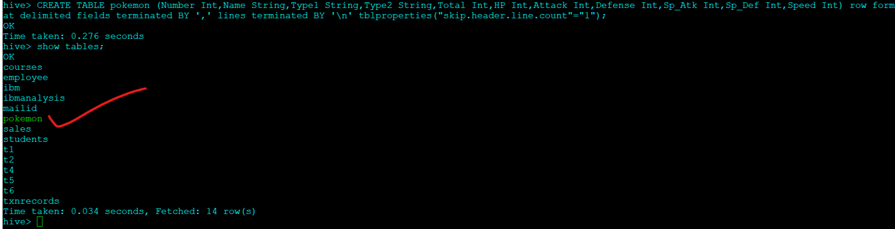

The above command will create a table called ‘pokemon’, with the fields as shown in the dataset description. We have given the parameter to skip the header line, so while loading the dataset, this ‘pokemon’ table will ignore the header line

Let ‘s Load the Data into table Pokemon

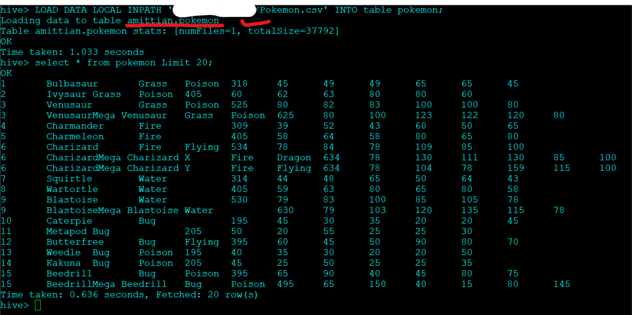

Data is loaded successfully into amittian.pokemon

Where amittian is schema name and pokemon is the name of table.

Problem Statement 1: Find out the average HP (Hit Points) of all the Pokémons

select avg (HP) from pokemon;

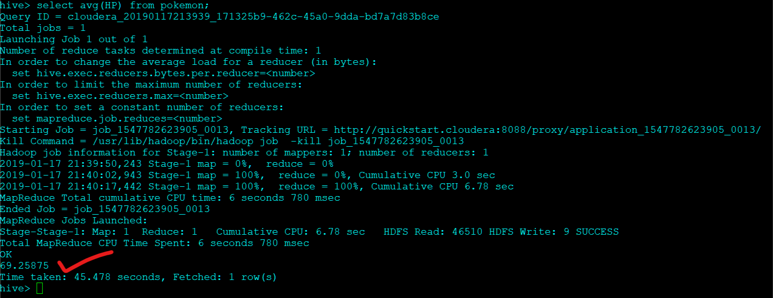

Average HIT POINT of the pokemon player is 69.26

We also connect our tableau Desktop to this hive table [ amittian.pokemon ]to interpret the result , but not just limited to interpretation but also give insight quickly , more nicer and understandable format .

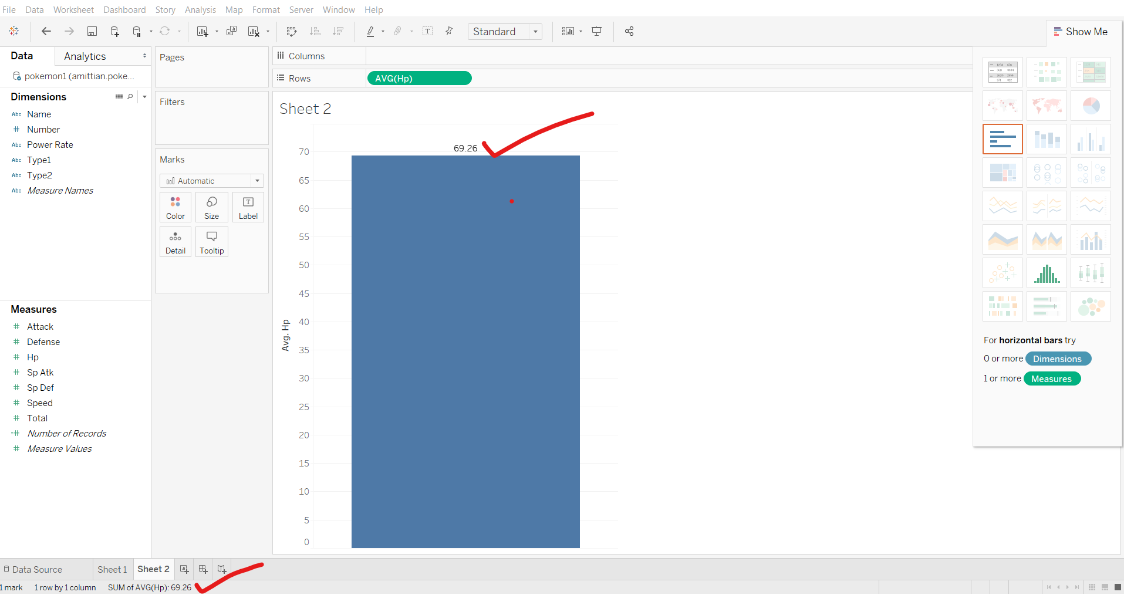

well here nothing impressive so far about tableau , as complexity increases ;we will see the actual power of tableau ,how we are able to get insight quickly in more untestable format .

Problem Statement 2:

Create and insert values of the existing table “pokemon” into a new table “pokemon1,” with an additional column “power_rate” to find the count of “powerful” and “moderate” from the table “pokemon1.”

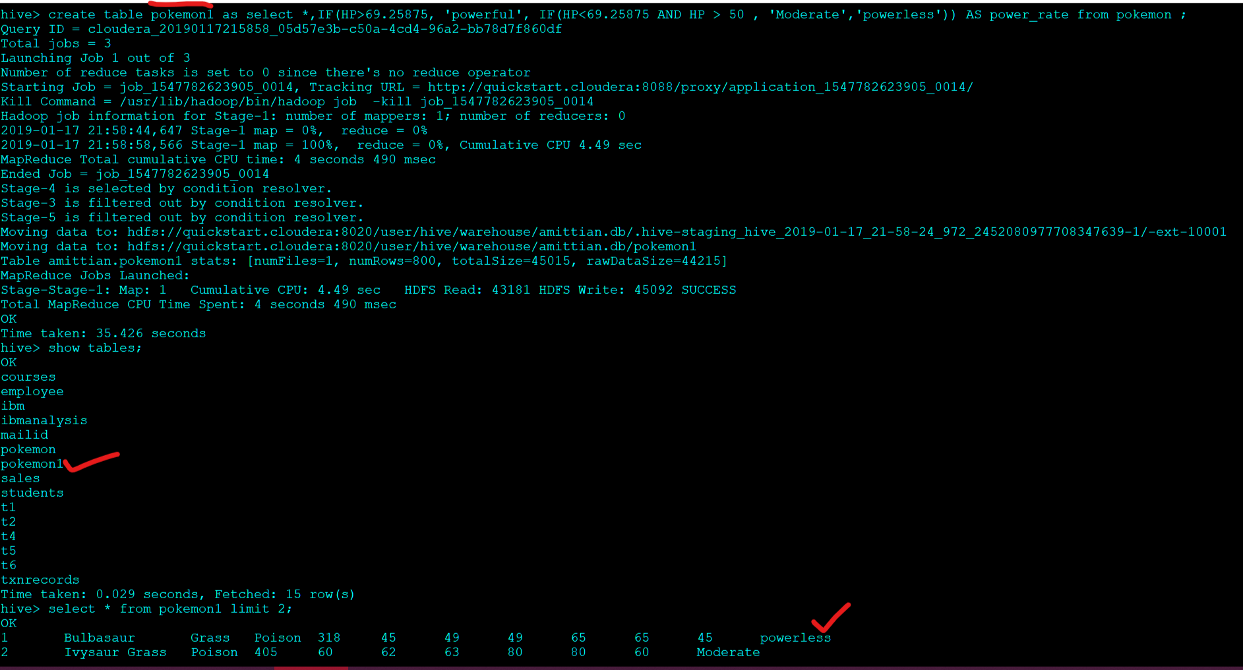

Let 's check how many players belongs to each category.

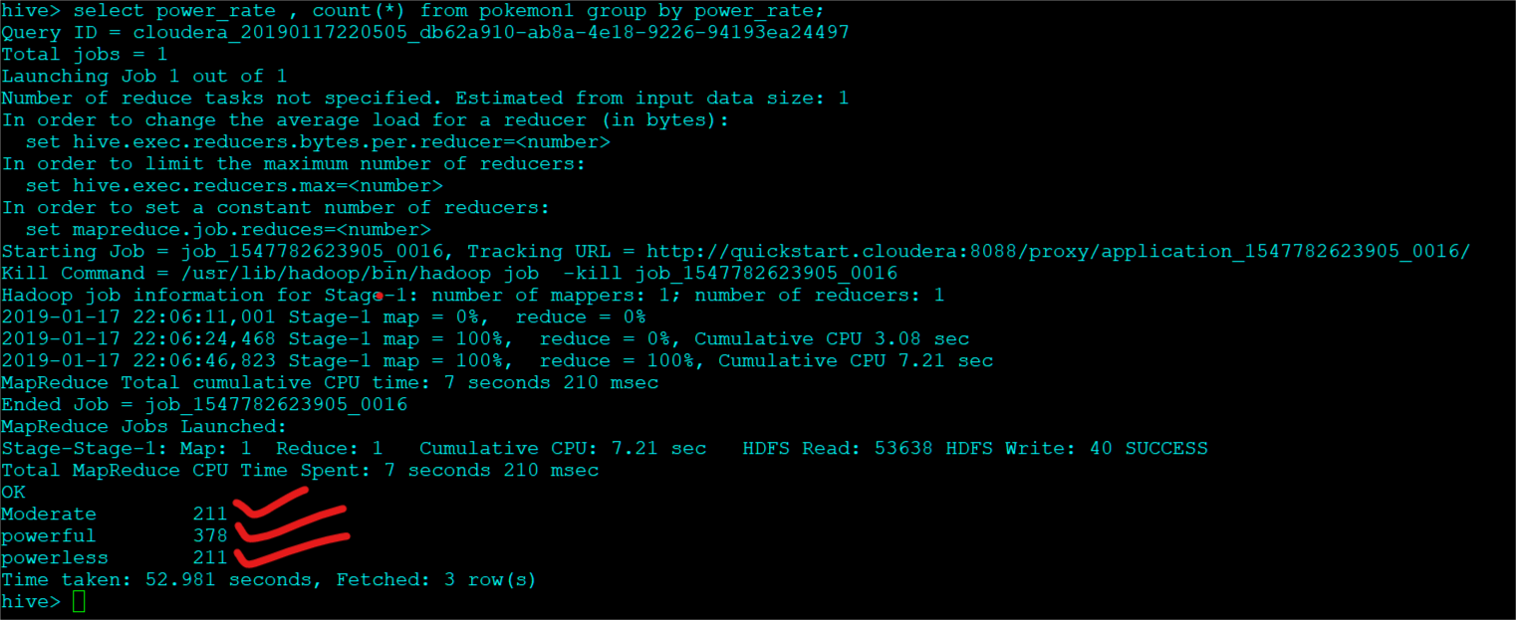

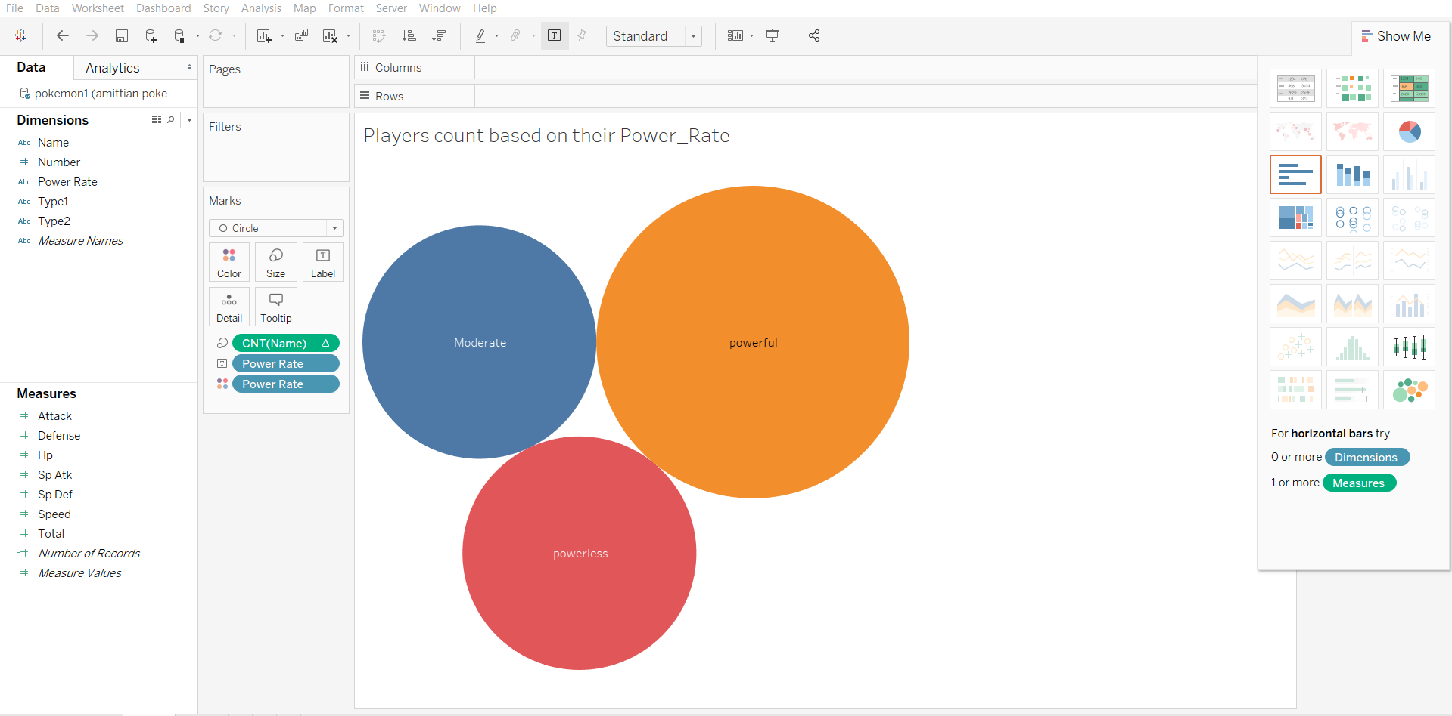

Problem Statement 3:

Find out the top 10 Pokémons according to their HP’s

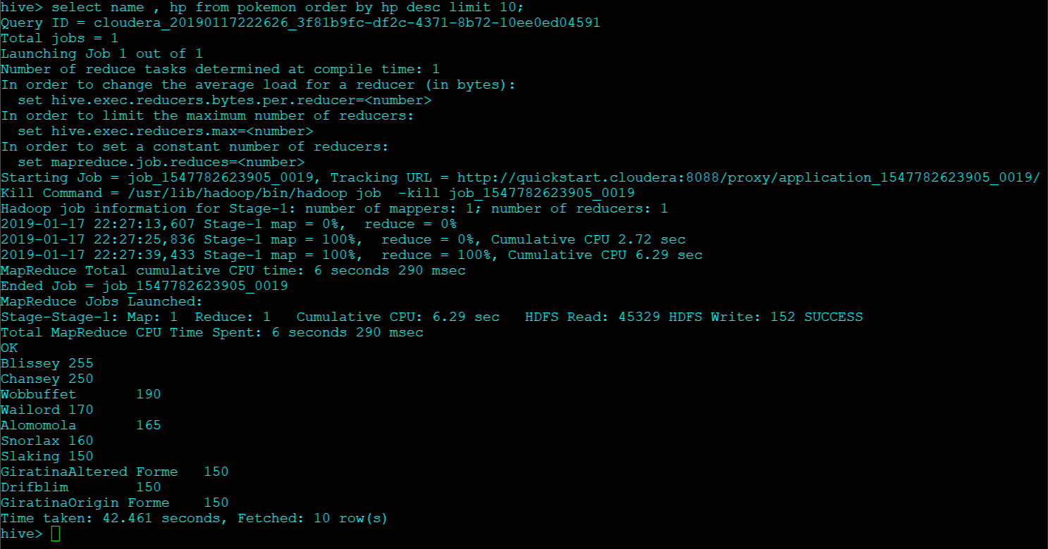

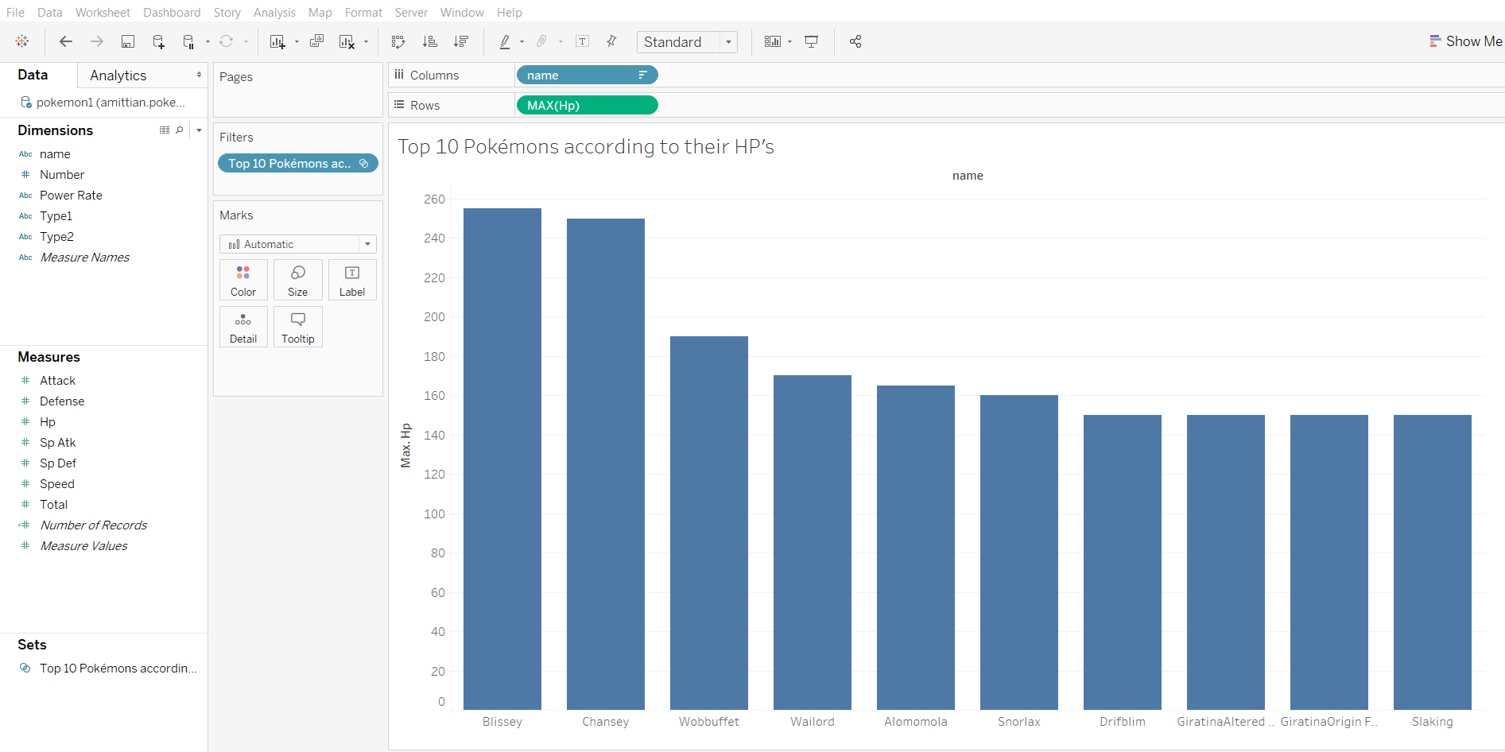

Problem Statement 4:

Find out the top 10 Pokémons based on their Attack stat

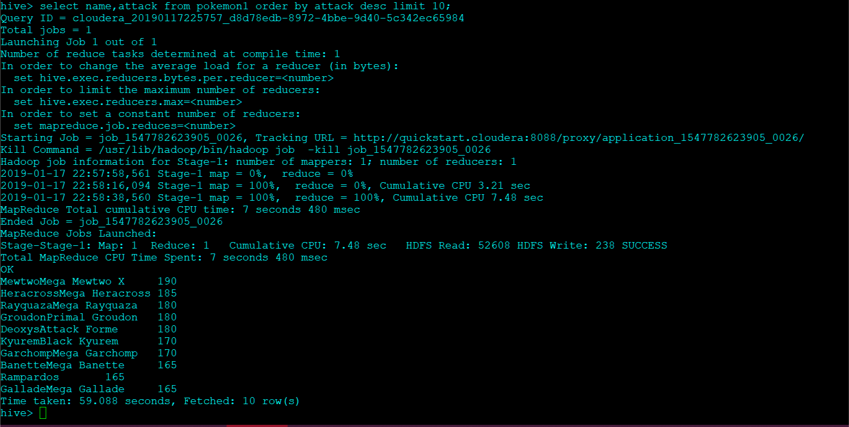

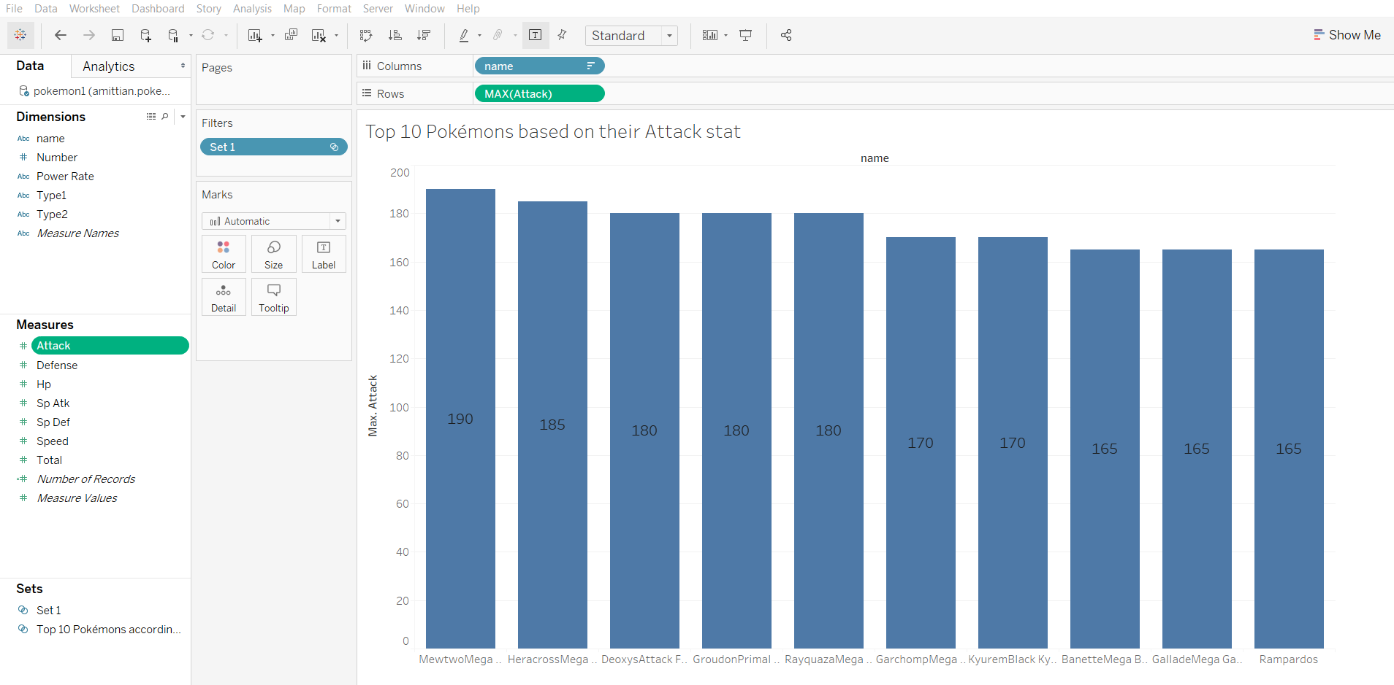

Problem Statement 5: Find out top 10 Pokémons based on their defense stat

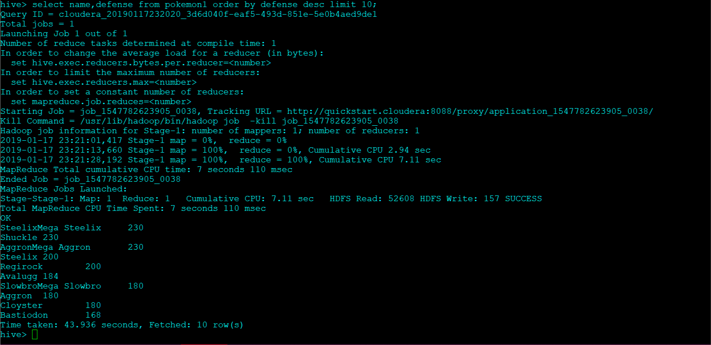

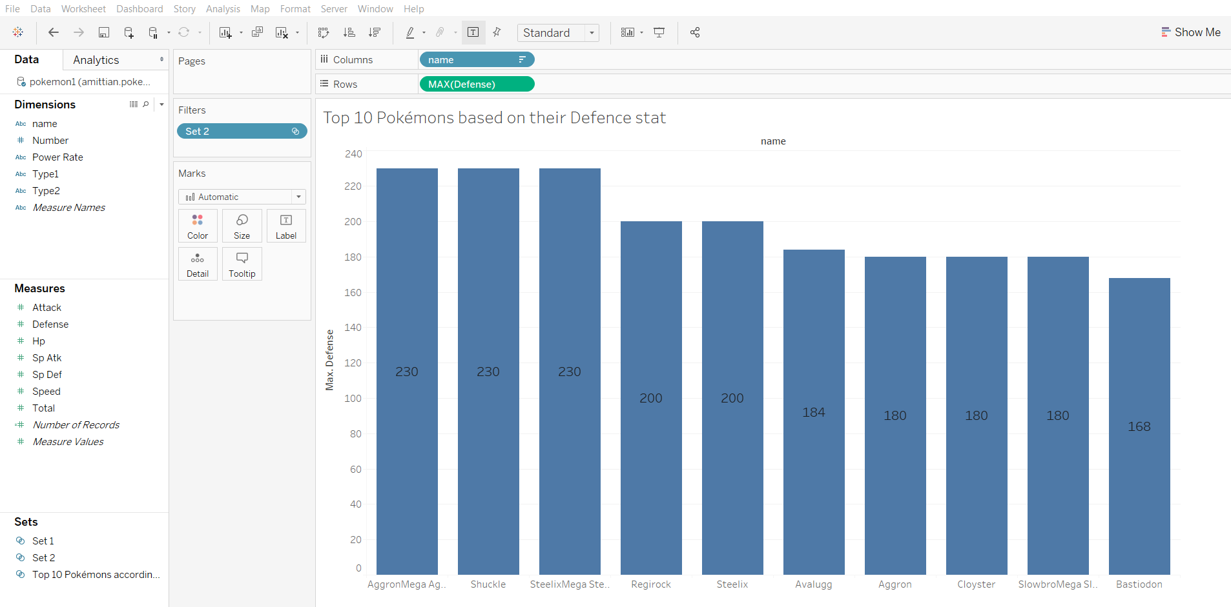

Problem Statement 6: Find out the top 10 Pokémons based on their total power

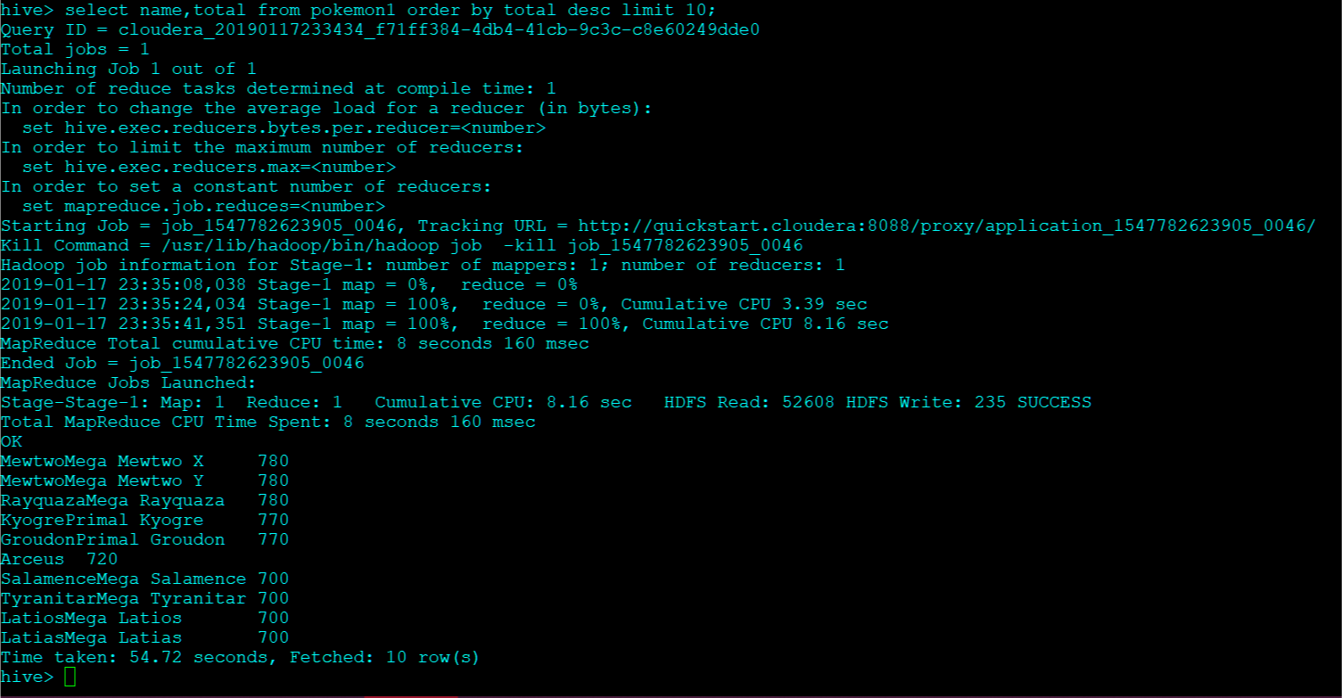

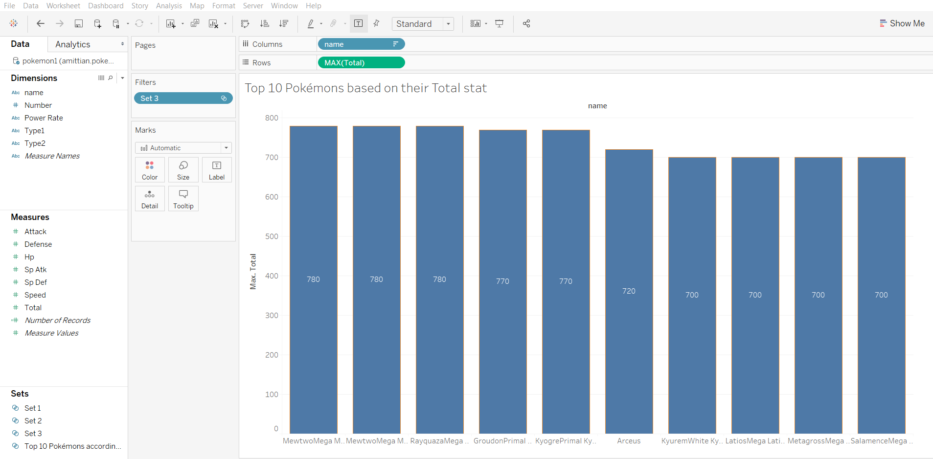

Problem Statement 7:

Find out the top 10 Pokémons having a drastic change in their attack and sp.attack

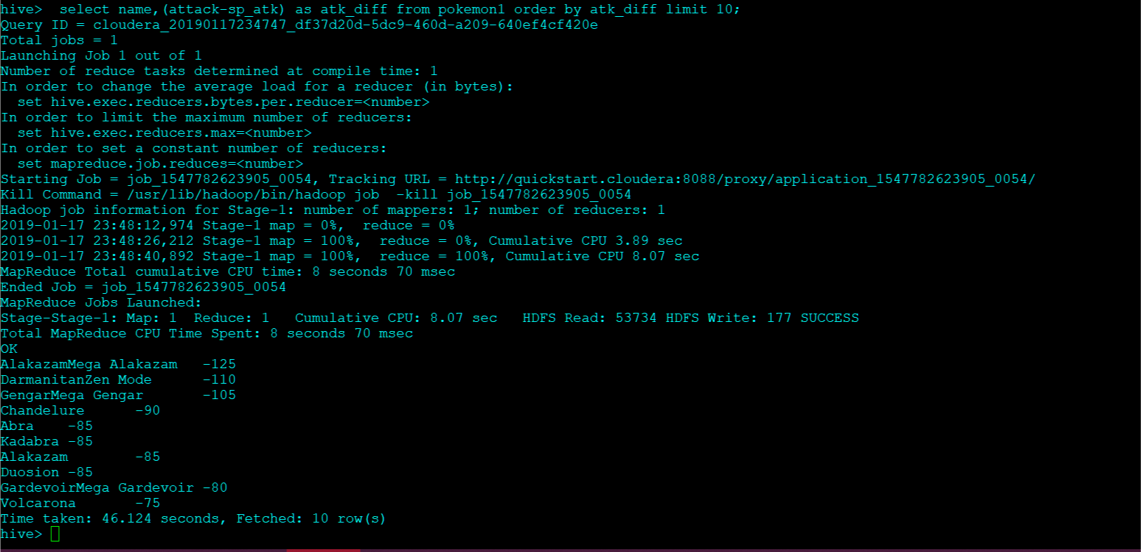

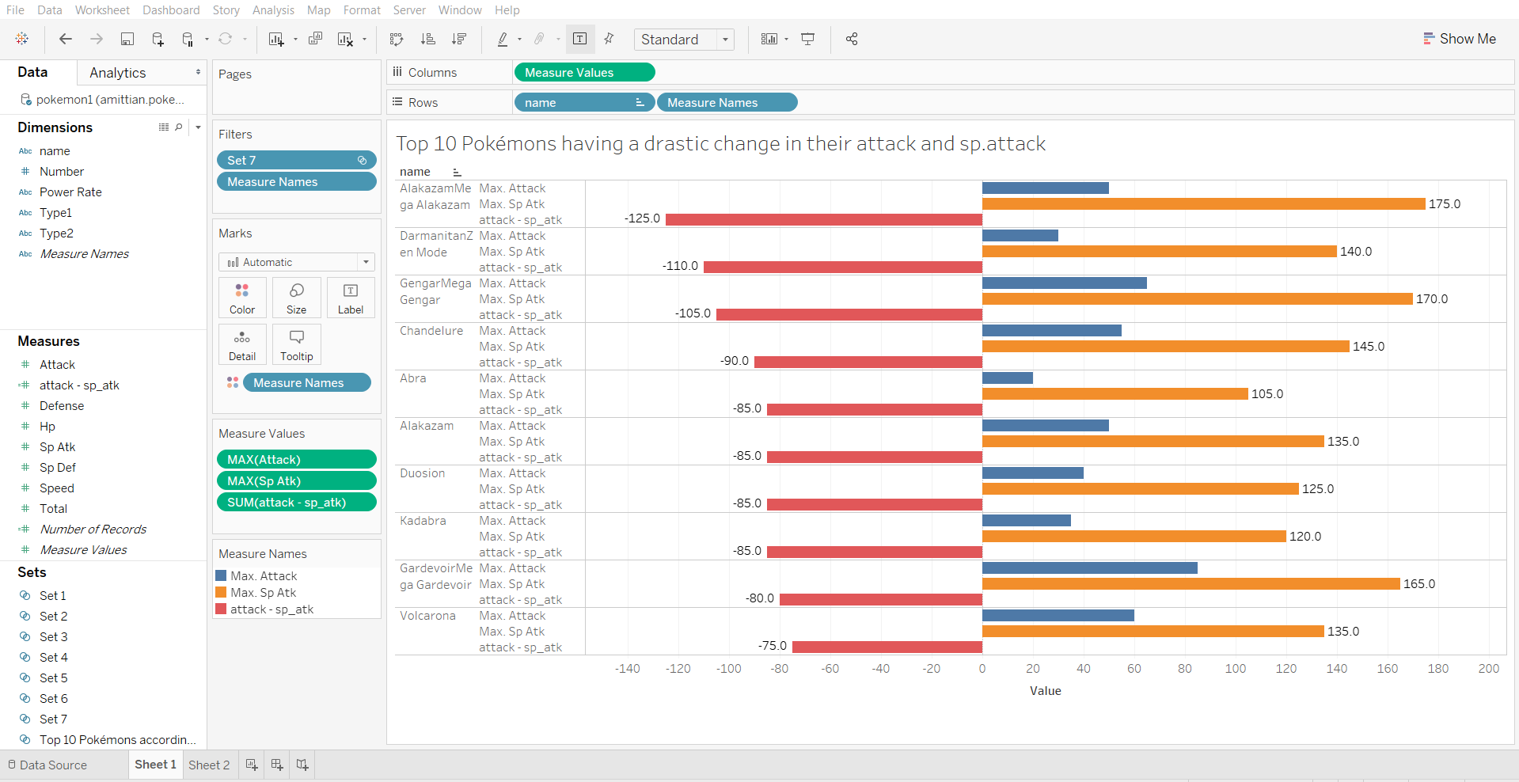

Problem Statement 8: Find the top 10 Pokémons having a drastic change in their defense and special defense

